**LAB 8**

**Q1: IN LAB**

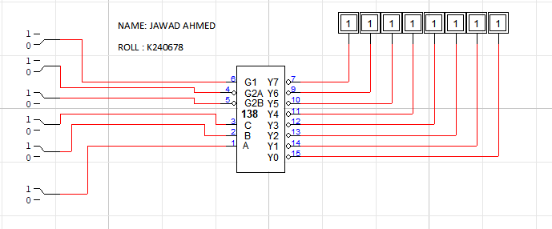

|  |  |  |  |  |  |  |  |  |  |  |  |  |  |
| --- | --- | --- | --- | --- | --- | --- | --- | --- | --- | --- | --- | --- | --- |
| **INPUTS** | | | | | | **OUTPUT** | | | | | | | |
| **ENABLE** | | | **SELECT** | | |
| **G1** | **G2A’** | **G2B’** | **A2** | **A1** | **A0** | **Y0’** | **Y1’** | **Y2’** | **Y3’** | **Y4’** | **Y5’** | **Y6’** | **Y7’** |
| **1** | **0** | **0** | **0** | **0** | **0** | **0** | **1** | **1** | **1** | **1** | **1** | **1** | **1** |
| **1** | **0** | **0** | **0** | **0** | **1** | **1** | **0** | **1** | **1** | **1** | **1** | **1** | **1** |
| **1** | **0** | **0** | **0** | **1** | **0** | **1** | **1** | **0** | **1** | **1** | **1** | **1** | **1** |
| **1** | **0** | **0** | **0** | **1** | **1** | **1** | **1** | **1** | **0** | **1** | **1** | **1** | **1** |
| **1** | **0** | **0** | **1** | **0** | **0** | **1** | **1** | **1** | **1** | **0** | **1** | **1** | **1** |
| **1** | **0** | **0** | **1** | **0** | **1** | **1** | **1** | **1** | **1** | **1** | **0** | **1** | **1** |
| **1** | **0** | **0** | **1** | **1** | **0** | **1** | **1** | **1** | **1** | **1** | **1** | **0** | **1** |
| **1** | **0** | **0** | **1** | **1** | **1** | **1** | **1** | **1** | **1** | **1** | **1** | **1** | **0** |

**Q2: IN LAB**

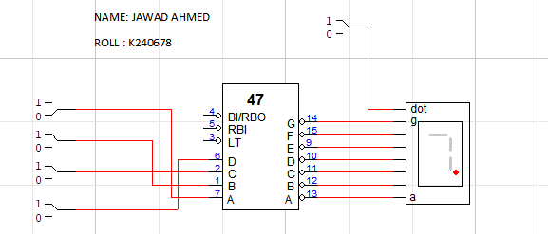

|  |  |  |  |  |  |  |  |  |  |  |
| --- | --- | --- | --- | --- | --- | --- | --- | --- | --- | --- |
| **INPUT** | | | | **OUTPUT** | | | | | | |
| **A3** | **A2** | **A1** | **A0** | **A’** | **B’** | **C’** | **D’** | **E’** | **F’** | **G’** |
| **0** | **0** | **0** | 0 | **0** | **0** | **0** | **1** | **0** | **0** | **0** |
| **0** | **0** | **0** | **1** | **1** | **0** | **0** | **1** | **1** | **1** | **1** |
| **0** | **0** | **1** | **0** | **0** | **0** | **1** | **0** | **0** | **1** | **0** |
| **0** | **0** | **1** | **1** | **0** | **0** | **0** | **0** | **1** | **1** | **0** |
| **0** | **1** | **0** | **0** | **1** | **0** | **0** | **0** | **1** | **0** | **0** |
| **0** | **1** | **0** | **1** | **0** | **1** | **0** | **0** | **1** | **1** | **0** |
| **0** | **1** | **1** | **0** | **0** | **1** | **0** | **0** | **0** | **0** | **0** |
| **0** | **1** | **1** | **1** | **0** | **0** | **0** | **1** | **1** | **1** | **1** |
| **1** | **0** | **0** | **0** | **0** | **0** | **0** | **0** | **0** | **0** | **0** |
| **1** | **0** | **0** | **1** | **0** | **0** | **0** | **0** | **1** | **0** | **0** |

**Q1: Post Lab  
